**Karman, Gill**

**Module A.4: Computing history**

**Level 0: Personal Computer Internals**

Labeled motherboard :

Ram Slots

Cpu cooler

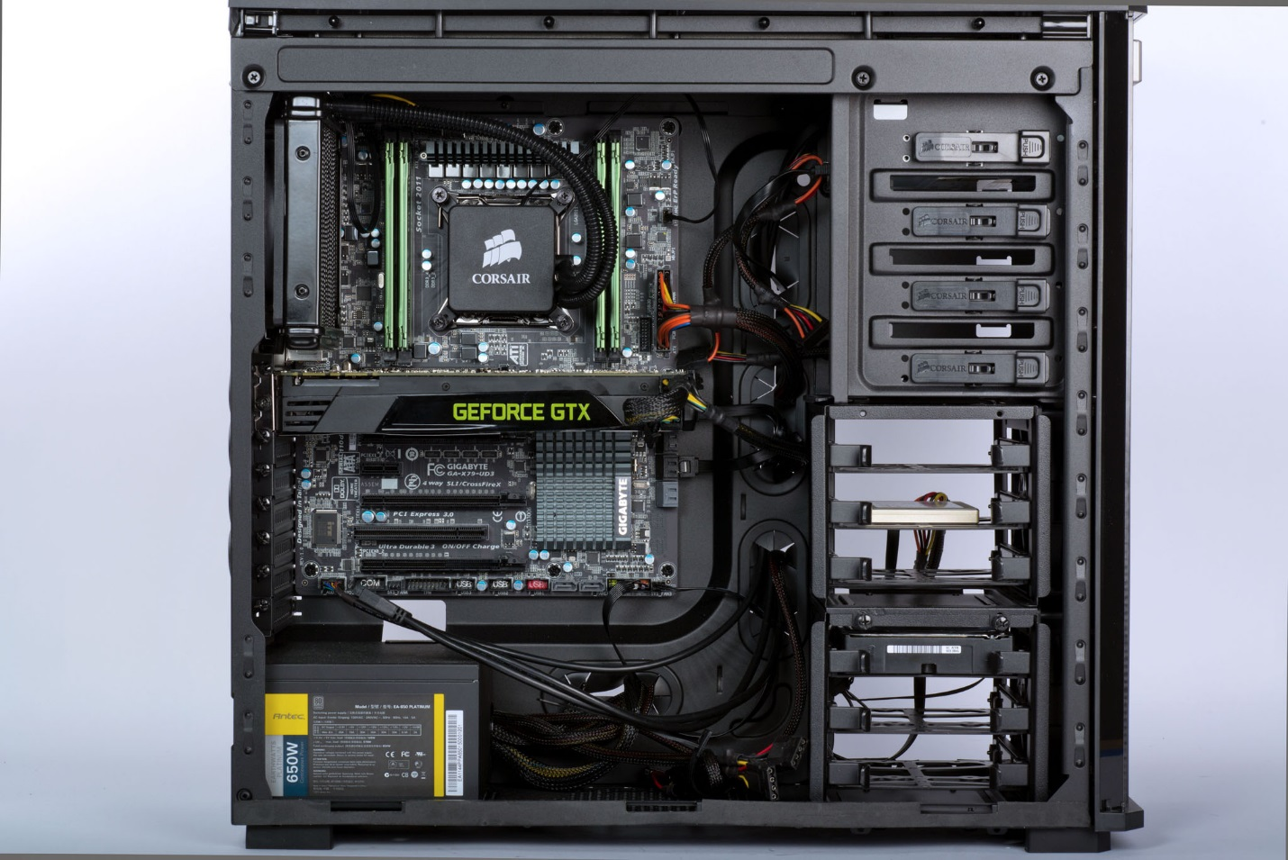

Hard Drive

CPU cooler

Power supply

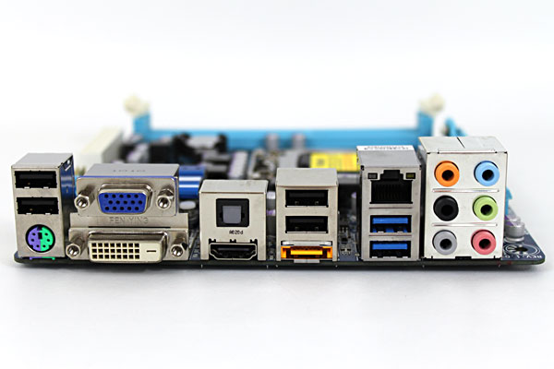

PCI – E

Connectors

6 sound ports

Ethernet port

HDMI Port

VGA Port

Mouse/keyboard Connector

**Level 1: History of Computers**

* Many of the first Main frame computers were produced within the years 1950’s all the way through the 1970’s.
* These computer were huge in size, taller than many humans
* Main frame computers are usually used by large organizations to process large amounts of information
* The first main frame computer was manufactured by IBM which solved addition and multiplication problems in less than six seconds.
* The UNIVAC was the first commercially available computer for people to use
* the Univac handled both numbers and alphabetic characters equally well. the univac i was unique in that it separated the complex problems of input and output from the actual computation facility
* The machine was 25 feet by 50 feet in length, contained 5,600 tubes, 18,000 crystal diodes, and 300 relays. It utilized serial circuitry, 2.25 MHz bit rate, and had an internal storage capacity 1,000 words or 12,000 characters.
* The ENIAC, the first large-scale computer to run at electronic speed without being slowed by any mechanical parts.

**Computers in the 1960’sand 70’s**

**1960’s**

* In the 1960’s the Mainframe computer was just being improved like making parts smaller and more reliable transistors
* and was getting more public than compared to the 1950’s
* Computers were now available to the public
* Some games were also programmed
* The computers were getting more advanced and could do more than the computers in the 50’s some things include
* Some new software/program languages were being developed like:
  + COBOL
  + CTSS
  + And many more
* The US Navy Tactical Data System uses computers to integrate and display shipboard radar, sonar and communications data

**1970’s**

* The introduction of the ATM’S
* Newer programming languages are introduced
  + Pascal
  + C
* Computers began to downsize
* Arcade games are developed(Computer space one of the earliest)
* Hand held scientific calculators
* The laser printer is invented at Xerox
* We got to see more network like the Email
* Pong
* More productivity type computer like drawing systems like super paint
* TV typewriters
* The IBM 3850 mass storage system is introduced
* Xerox PARC Alto introduced, this computer had a massive impact on the computer industry. It was based on a graphical user interface using windows, icons, and a mouse, and worked together with other Altos over a local area network. It could also share files and print out documents on an advanced Xerox laser printer.
* The Apple 1
* Apple II introduced, Sold complete with a main logic board, switching power supply, keyboard, case, manual, game paddles, and cassette tape containing the game Breakout.
* The 70’s were mainly big about the upcoming personal computer

**Modern Main frame computers**

* Banks use main frame computer so we can interact with our bank account.
* Main frame computers are used by large corporations (e.g. Apple), banks, and governments
* Until the mid-1990s, mainframe computers provided the only acceptable means of handling the data processing requirements of a large business.
* Because of these design strengths, the mainframe is often used by IT organizations to host the most important, mission-critical applications.
* Many of today's busiest Web sites store their production databases on a mainframe host.
* Corporations use mainframes for applications that depend on scalability and reliability. For example, a banking institution could use a mainframe to host the database of its customer accounts, for which transactions can be submitted from any of thousands of ATM locations worldwide.

**Businesses today rely on the mainframe to:**

* Perform large-scale transaction processing (thousands of transactions per second)
* Support thousands of users and application programs concurrently accessing

numerous resources

* Manage terabytes of information in databases
* Handle large-bandwidth communication

1. **Supercomputers**

* the Cray CDC 6600 supercomputer was introduced, as one of the world's first supercomputers - and was considered to be the most powerful computer in England
* Known as the first successful supercomputer
* it outperformed its fastest predecessor, the IBM 7030 Stretch, by a factor of three
* The first CDC 6600's were delivered in 1965 to the Livermore and Los Alamos National Labs

**Network computers**

* A computer that is connected with one or more other computers for the purpose of communication and file sharing.

**Quantum computer**

* a computer that makes use of the quantum states of subatomic particles to store information.

**Massive parallel computers**

* The Deep blue was a computer which was a masters at chess
* Deep blue was not the best computer as it had terrible specs

1. **Personal computers**

* The IBM PC was introduced August 12, 1981, which were 36 years ago It is IBM model number 5150.
* **Some of its features include:**
  + Floppy disk or cassette system. One or two internal floppy drives were optional.
  + First IBM PC to come with an internal hard drive as standard.
  + 5160 with XT/370 Option Kit and 3277 Emulation Adapter
  + With 3270 terminal emulation, 20 function key keyboard

**PC’s before IBM**

* MITS Altair 8800,
* IMSAI 8080,
* Apple 1
* Apple 2

**First Apple Pc**

* The first apple Pc Came out in April 11, 1976 which was 41 years ago
* The apple 1 was Quite different compared to the IBM PC, The main reason was because apple 1 was apples first PC and IBM were in the computer business for a long time, some differences include:
  + Apple 1 was homemade and IBM was assembled in a factory
  + Apple 1 had a wooden case and IBM PC had a plastic case
  + The IBM came with a separated keyboard and monitor while apple 1 was 1 piece
  + The IBM PC was worth $1,565 while the apple one was worth $666.66

**Modern PC vs Old**

* New PC’s are now cheaper compared to old ones
* New PC’s Better Graphics
* More applications and features
* Faster speed
* Better looks
* Getting smaller
* Etc

**Level 2: History of Computer Components**

**CPU Chips**

* Intel 4004 became the first general-purpose programmable processor on the market
* Federico Faggin was the leader for the 4004 project
* It was the first commercially available microprocessor by Intel
* It contained:
  + Maximum clock speed of 740 kHz.
  + Up to 92600 instructions per second.
  + Separate program and data storage.
  + 12-bit addresses.
  + 8-bit instructions.
  + 4-bit words.

**Integrated circuit**

* An electronic circuit formed on a small piece of semiconducting material, performing the same function as a larger circuit made from discrete components.
* Early computers depended on vacuum tubes to amplify electrical signals throughout the machine. Vacuum tubes were large, made of glass, and required regular maintenance: not exactly something that could be put into a consumer device.

**The evolution of CPU’s**

* early microprocessors were 8bit, the industry had moved on to 16bit and 32bit processing by the mid-1980s, which helped pcs to run multiple applications at once.
* Performance increased as the number of transistors on the microprocessor doubled every other year
* Demand for mobile phones was also growing at this time and, as it grew, so too did the need for energy efficient processing.

**RAM on the PC**

* On the PC the more Ram you have the better, this is because you need more ram soyou can multi-task more efficiently.

**Core Memory on older computers**

* Core memory does not use electricity to remember what data is written on it
* Core memory is much slower than RAM

**Moor’s law**

* Was an observation made by Intel co-founder Gordon Moore in 1965.
* Moore noticed that the number of transistors per square inch on integrated circuits had doubled every year since their invention.
* The law predicts that this trend will continue in the future
* Just like the transistors, RAM has also followed this law by the RAM decreasing through the years

**Ram and External memory**

* The hard disk is a memory that lets a user store and erase data. All data stored on the hard disk doesn’t clear during and after usage. The RAM does clear itself after a program has been used.
* Also the RAM data will be lost if there is no power
* Hard disk also contain more memory, ranging from 500GB to 8TB

**RAM over time**

* The biggest development Ram has had over time is the smaller size and much more space and more efficiency

**Video Cards**

* VGA means video graphics array
* is the display hardware first introduced with the IBM PS/2 line of computers in 1987.
* VGA cables have 15-pin connectors: 5 pins at the top, 5 in the middle, and the other 5 at the very bottom.
* VGA provides 640 x 480 resolution color display screens with a refresh rate of 60 Hz and 16 colors displayed at a time. If the resolution is lowered to 320 x 200, 256 colors are shown.

**Before VGA cards**

* 9 Pin subminiature

**3D graphics cards**

* The first 3d graphics card was The Nvidia GeForce 256
* It came out October 11, 1999
* **Some features it had:**
  + no less than 23 million transistors
  + D-pipeline that calculates the lighting of objects in relation to one or several light sources.
  + 480 Mpixels/s
  + resolution of 1600x1200
  + 'Fast Write'-feature enables the CPU to directly write to the graphics card's frame buffer without taking a detour through system memory

**Graphic cards over the time**

* The design has changed, now cards look more attractive and modern
* Better resolutions

**Level 3: History of Operating Systems**

**Software program and operating system**

* System software is a type of computer program that is designed to run a computer's hardware and application programs.
* Operating System is the software that supports a computer's basic functions, such as scheduling tasks, running applications, and controlling peripherals.

**What is a driver**

* a group of files that enable one or more hardware devices to communicate with the computer's operating system. Without drivers, the computer would not be able to send and receive data correctly to hardware devices, such as a printer.

**What is a service**

* a network service is an application running at the network application layer and above, that provides data storage, manipulation, presentation, communication or other capability

**Windows operating system**

* Dos is an operating system that runs from a hard disk drive.
* The only reason DOS is related to Windows is because both were an operating system
* Also the first windows system had an existing MS.DOS installation
* However, DOS was Not the best as you would have to enter a command for every little thing.

**Windows first system**

* Windows 1.0 was released on November 20, 1985, as the first version of the Microsoft Windows line
* Some features include:
  + It runs as a graphical
  + 16-bit multi-tasking shell on top of an existing MS-DOS installation.
  + It provides an environment which can run graphical programs designed for Windows

**Apple OS and Windows**

* Apple OS has a great history of no viruses, compared to the windows operating system which usually does get a virus
* The operating system has been neck to neck as of the appearance and features throughout the years
* There was also some controversy with bill gates stealing the idea of the apple os

**Windows throughout the years**

* Windows has gone through some big changes, at first the operating system was not the best, with very basic tools to use
* As the years went on Microsoft improved the way the system looked, and had more to offer to the user.
* Now it is one of the best operating systems in the world

**UNIX**

* Unix is a multiuser operating system
* is a set of programs that act as a link between the computer and the user?
* this system is not user friendly

**LINUX**

Just like Windows XP, Windows 7, Windows 8, and Mac OS X, Linux is an operating system.

* An operating system is software that manages all of the hardware resources associated with your desktop or laptop
* the operating system manages the communication between your software and your hardware. Without the operating system (often referred to as the “OS”), the software wouldn’t function.

**Link between Linux and Unix**

* the original Linux kernel was modeled after a version of UNIX, and even its creator at times has related it to UNIX.

**Unix and apple os**

* Apple os is related to Unix because apple os actually branched of and improved the original Unix software.
* Many other companies did the same